1. Build Array from Permutation:
#CODE:
import java.util.Arrays;

class Solution {
public int[] buildArray(int[] nums) {
int[] ans = new int[nums.length];

for (int i = 0; i < nums.length; i++) {
ans[i] = nums[nums[i]];
}

return ans;
}
}

OUTPUT:
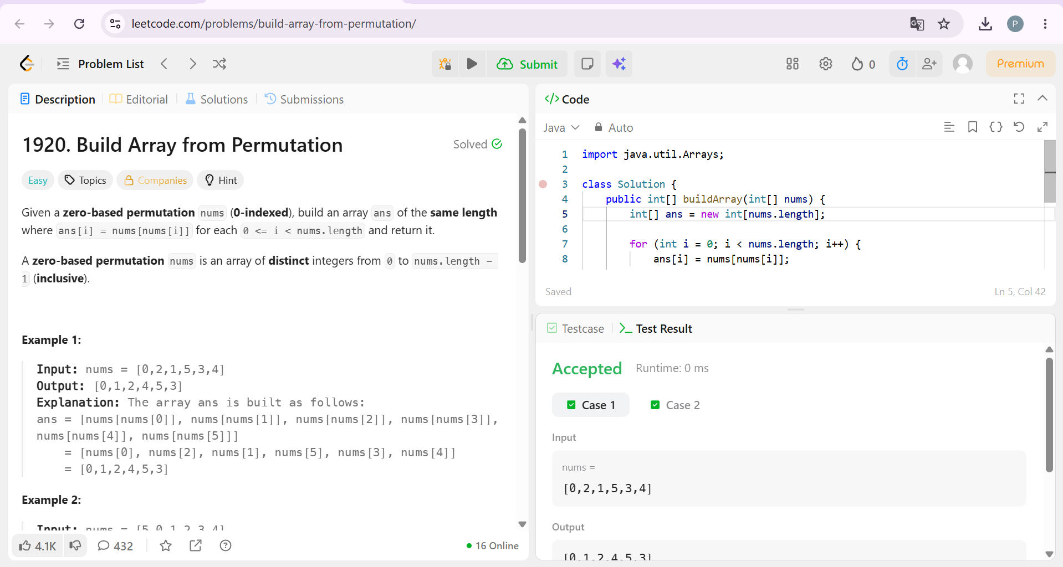

2. Shuffle the Array :
#CODE:
class Solution {
public int[] shuffle(int[] nums, int n) {
int[] ans = new int[2 * n];

int j = 0;

for (int i = 0; i < n; i++) {
ans[j] = nums[i];
ans[j + 1] = nums[i + n];
j += 2;
}

return ans;
}
}

OUTPUT:
